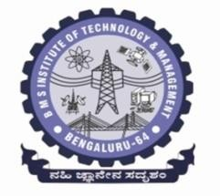 **BMS INSTITUTE OF TECHNOLOGY & MANAGEMENT**

**(An Autonomous Institution, Affiliated to VTU,Belagavi)**

Avalahalli, Doddaballapura Main Road, Yelahanka, Bangalore-64

**Department of MCA**

**Project – 2 [22MCA403]**

Student Name: USN:

Date of Submission:

Project Title:

|  |  |  |
| --- | --- | --- |
| **Sl. No** | **Particulars** | **Remarks** |
|  | Introduction |  |
|  | Literature Survey |  |
|  | Objectives |  |
|  | Proposed System |  |
|  | Modules Identified |  |
|  | Hardware and Software Requirements |  |

**Recommendations: Accepted (Y/N)**

**Suggestions by the coordinators**:

**/10**

**Evaluation by Guide:**

**Signature of coordinator**